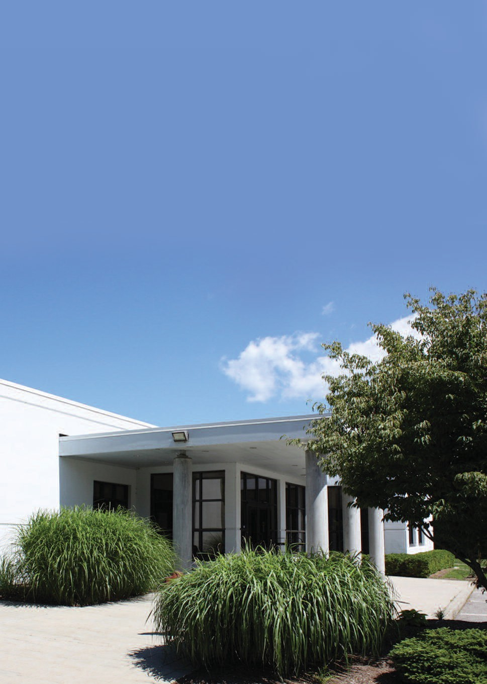

Litchfield Community Center

WELCOME TO THE
Litchfield Community Center

DID YOU KNOW THAT

0ver 8000 adults attend programs each year?

Over 2000 children and teens attend programs each year?

Over 4000 people attend more than 500 FREE programs each year?
Over 75 local organizations make use of the Center’s facilities each year?
And there’s more.

We hope you will enjoy the photographs and commentary that follow. They will take you on the journey of the Litchfield Community Center.
Come on along…

E x p l o r e. D i s c o v e r. E n j o y.

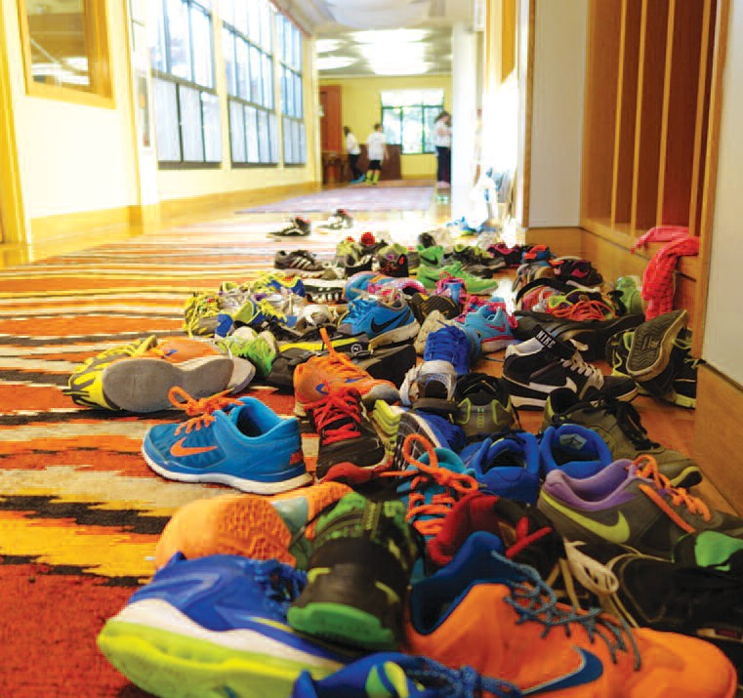
It all began in a church basement. Back in 1994 a group of energetic citizens started a teen center where youngsters could go to unwind and have fun. Then what had been a spark of an idea became a big reality when in 2000 the Litchfield Community Center opened and became the epicenter of the town, offering an extraordinary array of classes, lectures, trips, music, sports – something for anyone and everyone, regardless of age or interest.
Appealing to the senses, the imagination, and the lure of adventure in all of us, the Center has its finger on the pulse of what people want and desire.
The Center receives no funding from the Town of Litchfield and is totally reliant on contributions from the citizens of Litchfield, private foundations and surrounding communities.

i m a g i n a t i o n

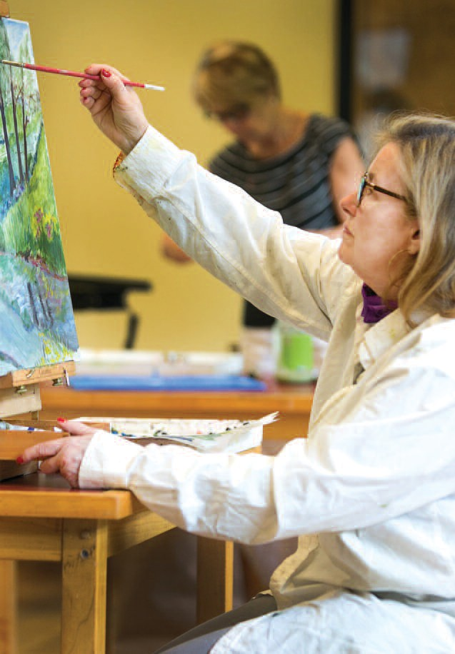
Whether physical or mental, the body and the brain need stimulation. Join us at yoga, zumba, tai chi, feldenkrais, or sculpt and tone with a pro who will show you the right way to exercise for maximum results. Challenge yourself with mah jongg, bridge, or cribbage. Paint with oils, watercolors or draw from live models. Make a quilt, learn to cook, make pasta. Challenge yourself and realize that goal you wished for and never attained. Whatever creative outlet you are seeking, chances are we have it covered. Our ever-evolving schedule is all about you. It will always be different and will always offer you the best.

c h a l l e n g e

The Center is much more than just kid-friendly. While schools continue to cut down the creative outlets for children, we keep adding to our repertoire. No need to have a bored child looking for something to do. Kids love food. We offer cooking classes geared just for them. Get creative with Christmas crafts, Ukrainian egg decorating, or enjoy a tie-dye party. There are teen dances,
Lego camp, jukebox bingo and music classes. Experience Friday fun days and family fun nights. If you have a suggestion for a new program, tell us about it. More than likely you will see it on our roster of activities in the not-too-distant future.

c e l e b r a t e

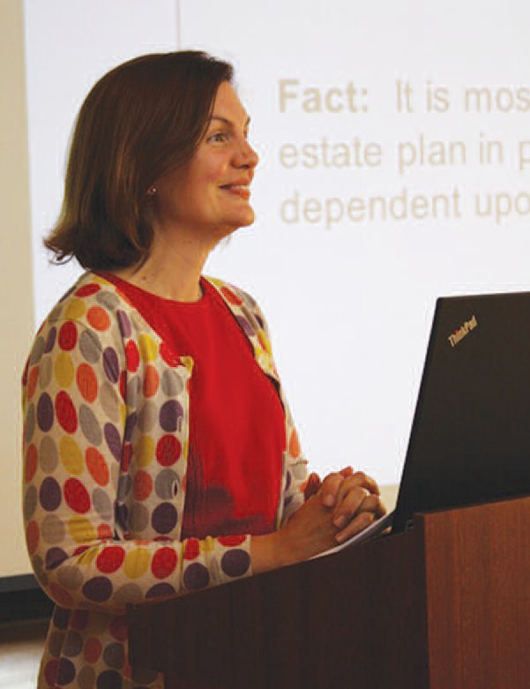
Sometimes just sitting back and listening is the greatest pleasure and at LCC you can do just that in countless ways. Lectures are offered on a variety of subjects by a host of experts. Learn about the First Ladies of the United States; discover more about the works of famous writers like Ernest Hemingway. Enjoy the music of Mozart and other classic musicians, meet local authors and hear about their new books and the process of writing. Need help decluttering and getting organized? We have someone who can help.
Missed a first-run movie? Every Monday the Center screens
a recent movie. The list of topics is endless and the quality of the speakers is impeccable.

g r o w t h

Everyone enjoys a surprise and we try to supply them. Recently we introduced Jazz Nights. The Center is transformed into a New York cabaret, replete with jazz combo, candlelight and drinks. AND vocal talent extraordinaire. The perfect Saturday date night event and it doesn’t involve having to go into the city. Dress up, order a cocktail and even have a dance or two if you choose. Or take advantage of our Brewfest. Or our major event Summerfest where you can experience a circus, feel as if you are on an ocean liner or traveling on the Orient Express. The creativity that goes into planning these events is unsurpassed and a good time is always had by all.
No silent auctions, no live auctions. Buy one raffle ticket or dozens and win the one major prize -- the trip you’ve always dreamed of.

s u r p r i s e

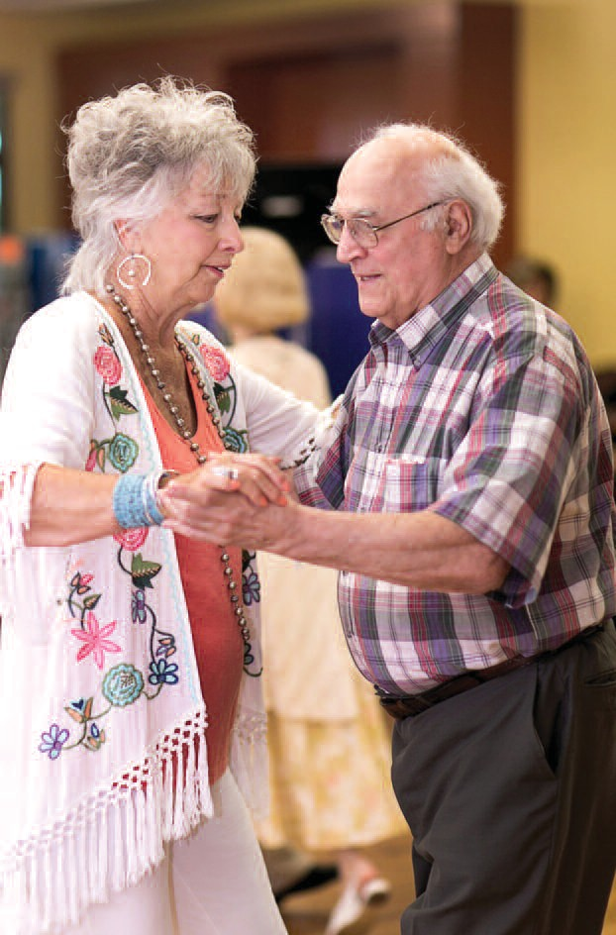
We all want to have fun, be entertained, or learn something new. But there is the practical side to dealing with life. And we can help you do that. Health care is on practically everyone’s mind these days. We have the experts who can lessen the confusion.
Understanding Medicare can help you navigate the issues.
Learn about the early detection of Alzheimer’s, become educated about Nursing Home Care, Checking Blood Pressure, Hearing Aid Screenings, and Life Line Screenings. Listen to a talk on brain fitness and food for life. Take the AARP safe driving course. No need to
fret about where to get the information – we have it and we want to share it with you. That’s what we’re here for.

s h a r e

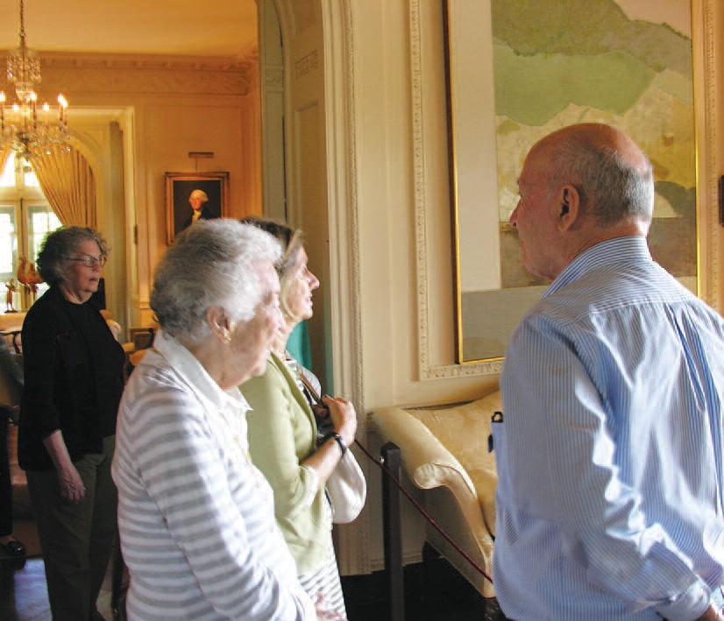
Discover new places, take that day trip to a museum or historic site and leave the driving to us. Explore the culinary wonders of Arthur Avenue in the Bronx, visit the famous Philip Johnson Glass House in New Canaan, enjoy a musical program at Tanglewood, and visit the Mattatuck Museum, a treasure not so far from the
Center. Sign up for four day trips to museums you’ve always wanted to visit, complete with a docent. Experience the New York Botanical Gardens or just enjoy a day in New York and do whatever you choose. There is always Six Flags Adventure Park, Ocean Beach
in the summer or UConn sports games. Visit Yale or Cambridge for a different taste of New England. The best part is you don’t need a car – just some time to enjoy the rewards of living where we do. And who knows what other trips are on the horizon?

e x p e r i e n c e

In a community such as ours, there are countless organizations and volunteer groups that convene on a regular basis. Not all
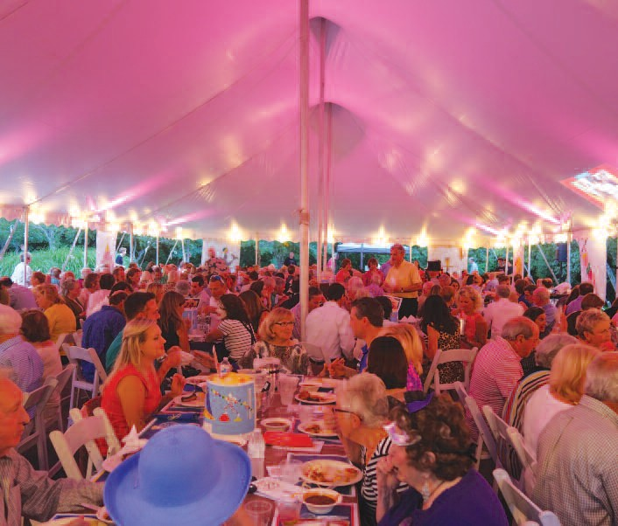
of these have their own meeting rooms. The Litchfield Community Center can solve that problem. We offer a variety of spaces for meetings, presentations, and gathering places. The Litchfield Hills Audubon Society, League of Women Voters, Litchfield Area Business Association, Women’s Forum of Litchfield, and the Litchfield Garden Club are a few of the groups that use our facilities and many of these meetings are open to the public – a chance to learn more about what goes on in our town..

c o m m u n i t y

Berta Andrulis Mette (center) and her staff are what make the Litchfield Community Center the special place that it is.
The dedication and enthusiasm of this team are unsurpassed. They work relentlessly to make the Center the best that it can be.
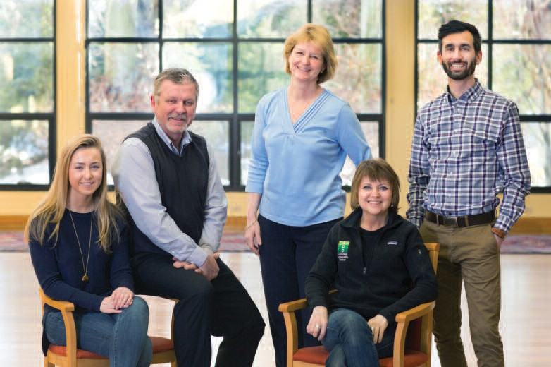
They are always on the lookout for a new idea, a new class, lecture, a new challenge, an innovation to enhance what is already offered. Readily available and always upbeat these are the people that make the Litchfield Community Center the gem that it is.
left to right: Emily Snowden, Rob Andrulis, Berta Andrulis Mette, Cheryl Mendez, David Hunt.

s u p p o r t

IN CLOSING

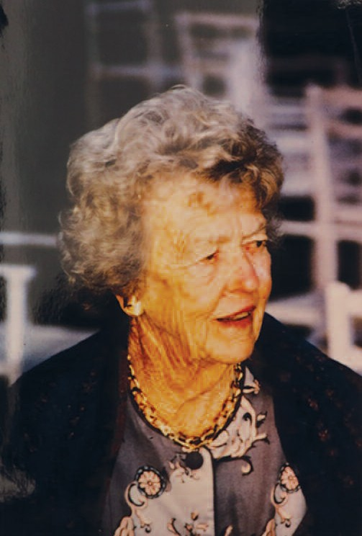
The Litchfield Community is most fortunate to have an extraordinary staff and a Board of Directors who understand
its mission. From that modest beginning in a church basement it has become a focal point and integral part of the Litchfield Community. Much of its growth is due to the dedication and
perseverance of one of its founders – Sonia “Sunny” P. Seherr-Thoss. It was she who believed in the idea and supported it both emotionally and financially. We are forever in her debt

d e d i c a t i o n

Litchfield Community Center

421 Bantam Road
L i tchfield, Connecticut 06759
p 860 567 8302 f 860 567 0328
www. thecommunitycenter. org info@ thecommunitycenter. org

